Group 27 CRN-46992-202002

Assignee’s:

Connor Delaney – 101325077

Jordon Jensen – 100740151

Julio Renaldi De Castro - 101295616

Michael Noseworthy – 101027533

Conceptual Data Model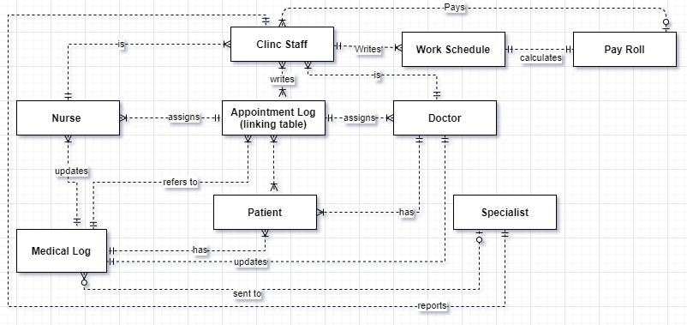

Logical/Physical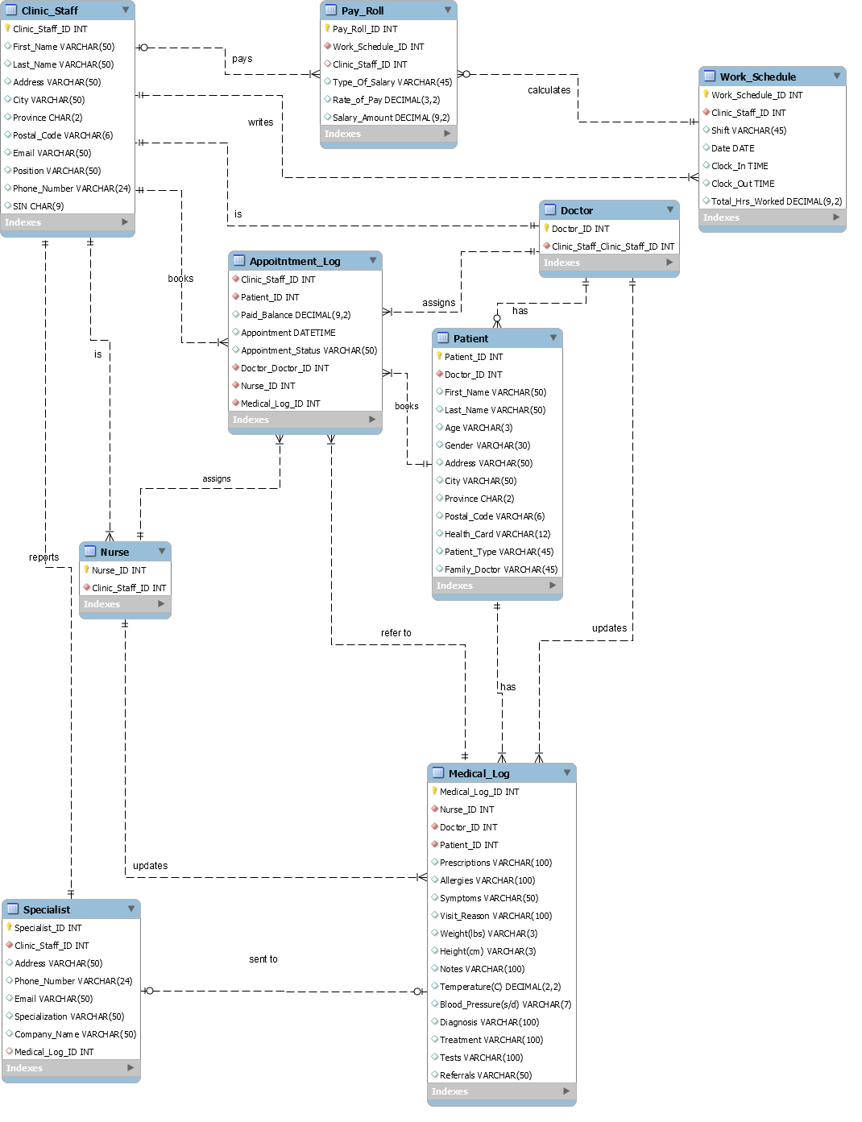

Create the following **TEN queries**

1. Create a query that returns Patients’ full names, addresses, phone numbers and email addresses. (Ten results minimum).



1. Create a query that lists all patients who have not had any appointment in the clinic in the last 2 years (at least one patient)

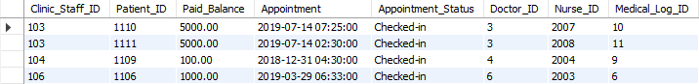

1. Create a query that returns the all appointment by a particular patient in the year of 2020 (should return 5 appointments at least) the result set would include patient names, examining doctors’ and nurses’ names, dates and times of the appointments, any tests ordered by the doctors for the patient.
2. Create a query that returns all appointments that were either cancelled, or patients were No Show in the month of December 2020. (five results minimum)
3. Create a query that that returns staff members’ names (excluding doctors), their hourly rates, number of hours worked and Salary (calculated column; there are 13 employees in the clinic) for the two weeks period (
4. The Clinic Manager has decided to send “Happy holidays” greeting cards in December and needs the full names and complete addresses (street address, city, province, Postal Code) for all the staff at the clinic (Doctors, nurses, patients, secretaries) so create a query that returns this information (usually called a mailing label)
5. Create a query that returns all patients enrolled permanently with one of the doctors
6. Create a query that returns a list of all patients and their family member (add a column primary member id in the patient table; make one patient as the primary member and then create another column called relationship and add husband, wife, son, daughter etc.)
7. Create a query that would create a list of all patients that were seen by a particular doctor on a given date (i.e. 12 December, 2020)
8. Create a query that would return name of a patient who paid some sort of a fee to the clinic, also retrieve the service for which he paid and the doctor’s name (for example Dr Smith, Sick Note)

Assumptions or Clarifications

-(not a table but an attribute of table payroll)Vacation days for salary (base rate for salary, amount saved for hourly), this should be a parameter because it can be used later on to calculate a staff members vacation pay when they take a vacation, otherwise when they don't show up to work they won't be paid.

- Table for the specialists they send patients out too, this keeps a detailed record of who was sent there, by which doctor, why and when it happened. Also handy to keep track of when a result has come back and gives staff an easy way to keep track of this data.

- Insurance Info, would hold the company name, type of coverage, address of the place, would be useful to help track and pay balances for patients.

- The project outline never specified if there should be a clock-in, clock-out with dates in order to keep adequate tracking of hours. This would need to be implemented in order to know precisely what an hourly workers hours would ultimately be to give them an accurate pay check.